Washington Glass Association

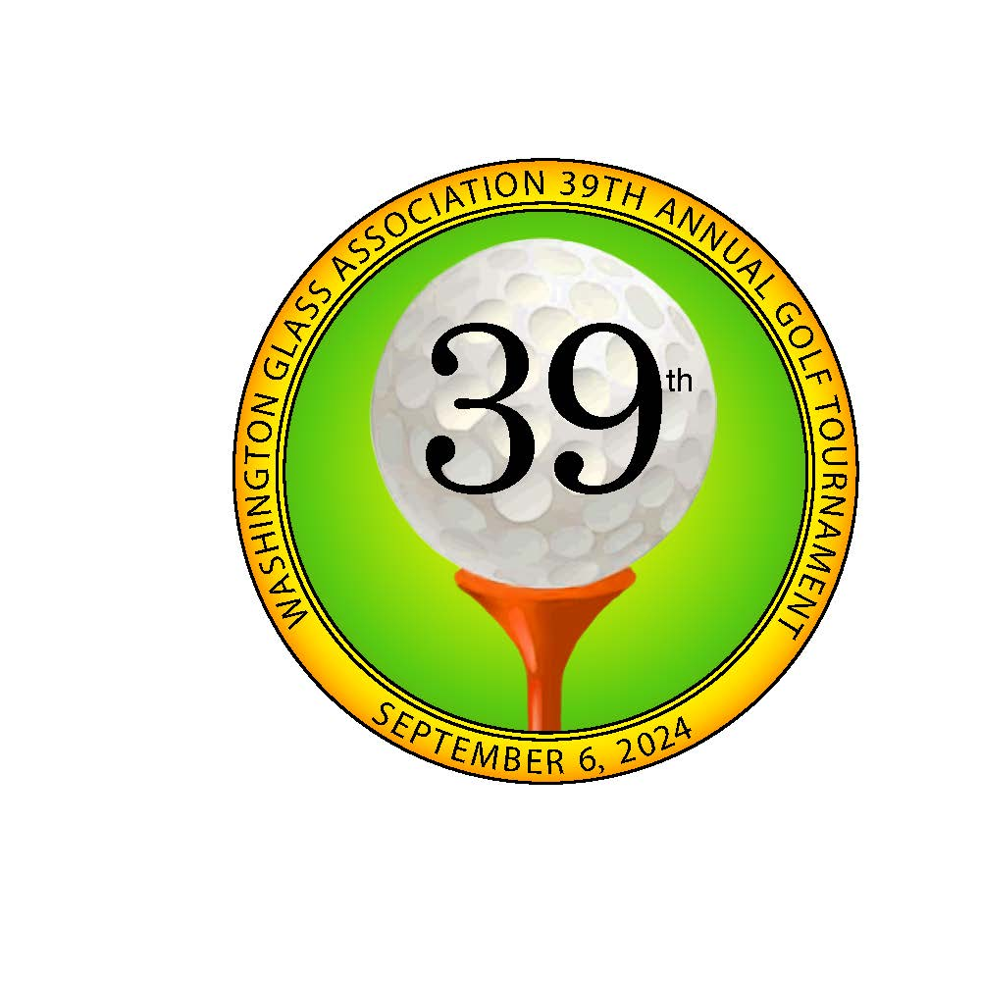

1733 H St. Suite 450 – Box 246  
Blaine, WA 98230 206.459.4029  
staff@wg-a.org

The WGA 39th Annual Golf Tournament five‐person scramble will be held on **Friday, September 6, 2024,** atTwin Lakes Golf & Country Club in Federal Way, Washington.

A **2024 GOLF SPONSORSHIP OF $285** is truly appreciated.

Your kind sponsorship supports the ongoing mission of the Washington Glass Association. One aspect of our mission is to promote education within industry and education in general. Last year’s WGA Golf Tournament raised a total of $3,300 in Scholarship contributions funded by our golfers. These funds were awarded on June 13, 2024, at our membership meeting. A grand total of $11,8.00 was awarded to family members of the WGA.

**Your Golf Sponsorship provides you with many benefits:**

*Your company’s name posted at a golf hole the day of the Golf Tournament.*



*Your name/company’s name posted at the Registration Table and the Golf Tournament Awards Banquet.*

*Your company’s name and your name posted online for a year. See 2023 Golf Sponsors on our website.*



***This year we are excited to include a silent auction at the tournament. Proceeds from the auction will be added to our scholarship awards.***

Name: ______________________________ Company Name:____________________________________

____ I would like to sponsor _____ hole(s) at **$285.00** each at the WGA 39th Annual Golf   
 Tournament. Enclosed is my check in the amount of $______________.  
 *(Multiple WGA Golf Hole Sponsorships are possible and welcomed.)*

____ I would like to donate the following Door Prize(s): _________________________________________  
____ I would like to donate an item to the silent auction. Please call the name & number below.  
 Name ______________________________________ Phone ________________________________  
____ I am interested in a special sponsorship to support the WGA Golf Tournament ‐ please  
 contact me at ______________________________________________________________________

Please charge my credit card: Visa: ____ M/C: ____ {No Amex}   
Credit Card Number: _________________________________________________________  
Name on Credit Card: _______________________________ Expiration Date: ___________  
Amount: $__________ Your Signature: __________________________________________  
**Email to: shirley.walsh@wg‐a.org**

2024 WGA Golf Tournament Print Sponsor **ICD High Performance Coatings + Chemistries**

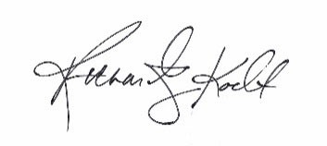

Sincerely,

Rick Koeller, Oldcastle Building Envelope

2024 WGA 39th Annual Golf Tournament Chair